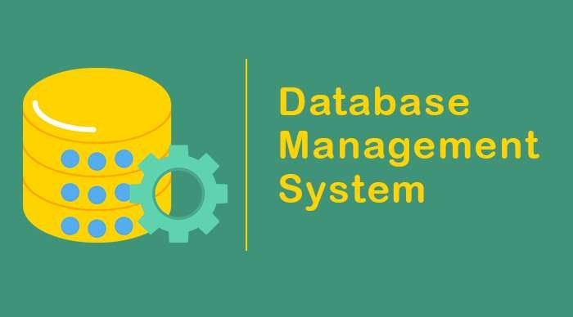

# What is Data And Database ?

# Data is different types of information usually formatted in a particular manner.

# Database is an organized collection of structured information, or data, typically stored electronically in a computer system.

What is DBMS ?

* A DBMS Consists of collection of set of application programs used to access, update and manage that data.
* A software system that allows users to store, manage, and manipulate vast amounts of data in a structured and organized manner.
* DBMS provides an interface between the users or applications and the underlying database, facilitating efficient data storage, retrieval, modification, and deletion.

# File System to DBMSDBMS vs File System | Top Most Useful differences You Need to Know

Advantages of DBMS

* Data Sharing
* Data searching
* Data Security
* Backup
* Maintenance

# Disadvantages of DBMS

# Comlex Structure of DBMS

# High Maintenance

# Compatibility

# Cost of Hardware and Software

Characteristics of Database approach

The database approach, also known as the database management system (DBMS) approach, is a method for storing, managing, and organizing data in a structured manner. It involves the use of a database management system to create, manipulate, and maintain databases.

1. Data Independence
2. Data Integrity
3. Data Security
4. Data Sharing and Concurrency Control
5. Data Querying and Manipulation
6. Data Scalability and Performance
7. Data Durability and Recovery

### Database Architectures

*1. Relational Database Management System (RDBMS) 2. NRDBMS/NoSQL*

*3. Distributed Databases*

Database Languages

1. **SQL (Structured Query Language)**
2. **MQL (MongoDB Query Language)**

## Popular DBMS Software

1. Oracle Database
2. MySQL
3. Microsoft SQL Server
4. PostgreSQL
5. MongoDB

## Database Administrator and its Responsibility

1. **Database Installation and Configuration**
2. **Database Design and Schema Management**
3. **Data Security and Access Control**
4. **Performance Monitoring and Tuning**
5. **Backup and Recovery**
6. **Database Maintenance and Upgrades**
7. **Data Replication and High Availability**
8. **Capacity Planning and Scalability**

Schema ,Instance and Schema Architecture

**Schema:** A schema represents the overall design and layout of the database

objects, such as tables, views, indexes, and constraints.

**Instance:** It represents the actual data stored in the database system, including the

content of tables, indexes, and other database objects.

**Schema Architecture:** Schema architecture refers to the design and organization of schemas within a database system.

* 1. *Single-schema architecture*
  2. *Three-schema architecture*

### Three-schema architecture

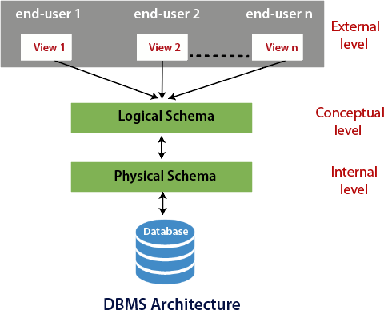

**Database System Architecture**

1. **Two-tier Architecture:** The two-tier architecture, also known as the client-server architecture, consists of two layers: the client layer and the server layer. In this architecture, the client layer directly communicates with the database server.

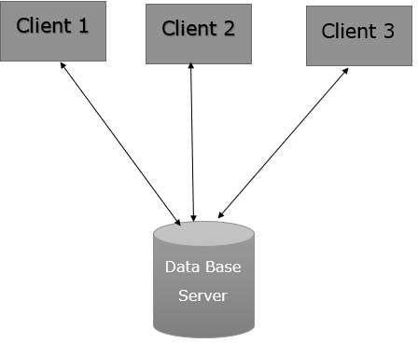

### Three Level ANSI-SPARC Architecture

